Instructions to the Candidate

You have been asked to refer a 18 year old male to the Neurosurgeons at QMC.

Your has been hit on the head with a cricket ball, around 6 hours ago. He does not open his eyes except to speech, and seems to be confused. His motor responses are normal. His pupils are both size 3 and react to light normally.

His GCS when he first arrived was 15. A CT head was arranged and reveals a large extradural haematoma. There is an overlying skull fracture (simple, not depressed).

The patient has no other medical history, takes no drugs, and has no allergies.

There was a delay in seeing the patient (he waited 1 hour to be triaged, and then a further 2 hours to be seen by the SHO), as initially his GCS was normal and his injury was thought to be quite minor.

Your involvement only started once the CT results were known. You have seen the patient, and discussed with the ED consultant (Dr Dorian) who has advised he should be transferred.

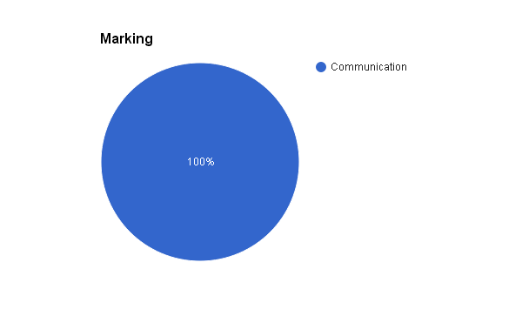

Instructions to the Examiner

OBJECTIVE: To assess whether the candidate can make a referral to a very dismissive specialist.

EXAMINER PROMPT: Please refer this patient to the neurosurgical registrar who is on the other end of the telephone line.

During the scenario, the candidate can be handed a copy of the OSCE candidate instruction sheet, so that they do not need to remember all the information. If the candidate asks you for any other information, hand them the following:

NAME WILLIAM SMITH
AGE 18
DOB 26 Sept 1998
HOSP. NO. s1212123

Instructions to the Actor

You are the on-call neurosurgical registrar, and are just about to go to theatres. As soon as the candidate calls you, you mention that you are very busy and need to go off to theatres.

You should interrupt their referral with questions and be slightly obstructive.

If the candidate suggests you look at the images yourself you should respond by asking are they not competent to interpret a CT - if this is the case then they should not be referring!

Be reluctant to accept the patient. Suggest do you have the ability to observe the patient in ED? They should say they have discussed with the ED senior and he is to be transferred

After this, ask the candidate the patient’s details.

If the candidate states that the injury happened 6 hours ago... ask “why’s it taken so long to refer the patient?”... end up saying “listen... just get the patient heret... I want him here within half an hour... and send the CTs with him, with your notes”.

Once they thank you, just hang up, without thanking the candidate.

If they ask: send the patient to D10, QMC, under c/o Mr Brain.

NAME WILLIAM SMITH
AGE 18
DOB 26 Sept 1998
HOSP. NO. s1212123

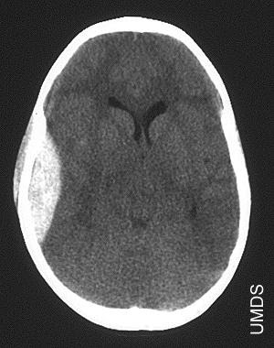

Mark Sheet: Station 48 (Difficult Referral Scenario)

Candidate:………………………………….. Examiner: ……………………………...

 | 1 | 0
Uses SBAR Structure
Situation: Who you are, Where you are calling from, Who you are speaking about, WhY you are calling.
Background: Age, Gender, PC, PMH.
Assessment: Diagnosis/ Problem List.
Recommendations: Transfer to you.
Gives GCS with breakdown.
Maintains need for transfer despite response of the neurosurgeon.
Does not get annoyed / angry with neurosurgeons.
Checks place to transfer patient.
Takes name of neurosurgical registrar.
Thanks the neurosurgeon / remains polite.

Global Score (1-5) ......……/ 5

Actor Score (1-5) ……….. /5
Total: ………………. / 20
(Pass mark: 15)

